A Quick Overview
of
Connecticut’s 2013 Race to the Top–Early Learning Challenge Application
⬧

Connecticut has applied for a Race to the Top-Early Learning Challenge grant for $37.3 million to improve the quality of early learning programs for young children in the state. The new Office of Early Childhood is the lead agency on the grant which proposes to increase access to high quality early learning experiences for young children with high needs by:
What is Race to the Top –
Early Learning Challenge?
- RTT-ELC is a competitive federal grant to states.
- The goal is to improve the quality of early learning programs for children before kindergarten, particularly children with high needs.
- 14 states were awarded this grant in the first 2 rounds, 2011 and 2012.
- These states are not eligible for round 3 funding.
- 16 states & Washington, D.C. applied in 2013, round 3.
- A total of $280 million is available in round 3.
- The upper limit for each state depends on the population of low-income children.
- The number of states awarded grants depends on the size of the states.
- Connecticut is eligible for $37.5 million over 4 years.
- Awards will be announced in early December.

- Implementing a system to rate the quality of programs
- Providing supports and incentives for programs to improve their quality
- Providing information and incentives for families to select higher quality programs

The Quality Rating & Improvement System

- Rates early learning programs using four quality levels.

- Quality levels are based on comprehensive program standards.

- The standards apply to center- and home-based programs as well as schools.

- The first level is basic health and safety determined by the state licensing system.

- At the top level programs meet national quality standards.

Supports and Incentives to Programs

- Grant funds are used to create five Quality Improvement Centers across the state.

- The centers provide programs technical assistance and professional development to move up the quality levels.

- Programs are eligible for annual Quality Awards that increase with program size and with the number of children with high needs served.
Information and Incentives to Families

- Program ratings will be posted on a web site and also available through the 2-1-1 Child Care statewide information call line at United Way of Connecticut.

- A statewide Early Childhood Quality public information campaign will be launched to provide parents with information about the importance of quality programs and about the new quality rating system.

- Professionals and community organizations that have contact with families will be trained to assist families in accessing quality early learning programs.

- The 2-1-1 Child Care information call center will hire additional staff members to assist families in accessing quality programs, focusing particularly on high needs families.

- The child care subsidy program will provide parents with incentives for selecting quality programs through a tiered rate system and a reduction of the parent co-pay at higher levels of quality.

Four Year Targets

- Currently there are about 360 programs at the highest level of quality serving about 22,000 young children with high needs.

- At the end of the 4 year grant period we project there will be over 900 programs at the highest levels of quality serving 31,500 children.

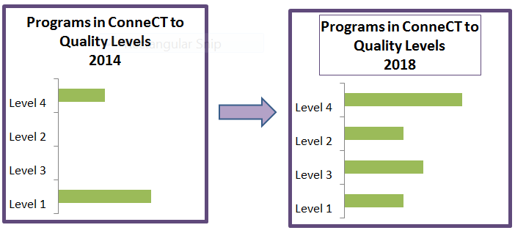

The overarching goal of Connecticut’s Early Learning Challenge application is to…
close the opportunity gap at kindergarten entry, proving all children with access to high quality programs.

This will make a significant difference in the lives of children with high needs in Connecticut and enhance their opportunity to enter kindergarten ready to succeed in school and in life.

Young Children with high needs includes children from birth to age five who are from low-income families or otherwise in need of special assistance and support, including those who have disabilities or developmental delays, who are English language learners, who reside on Indian lands, or who are migrant, homeless, or in foster care.

